Auxilock, GFS Mini Loop 55mm, Button 12mm
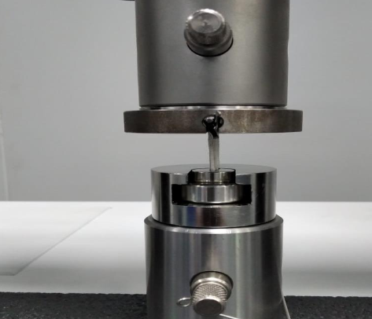

Fig: Test Setup

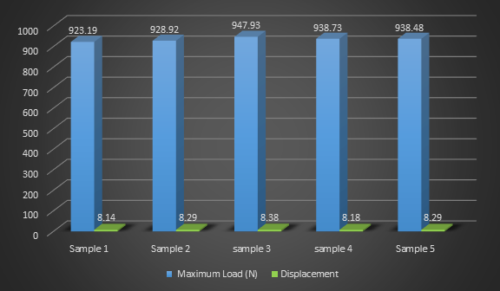

The graft fixation system Manufactured by M/S Auxein Medical Pvt. ltd. tested as per the internal protocol for static pull out test.

